


Center Place
Fine Arts & Civic Association, Inc.
DATE OF RENTAL

619 Vonderburg Dr. Suite B, Brandon, FL 33511
Office: (813) 685-8888
www.centerplacebrandon.com
Executive Director Email: Libby.Hopkins@centerplacebrandon.com

CENTER PLACE RENTALCONTRACT
Name of Renter
NAME OF ORGANIZATION, IF APPLICABLE

ADDRESS:

Street City State Zip
PHONE (Cell) (H) (W) Email: NAME OF PERSON PAYING DEPOSIT, IF DIFFERENT
ADDRESS:

Street City State Zip
PHONE (Cell) (H) (W) Email:
I have read the RULES AND REGULATIONS and CONTRACT which I understand and agree to abide by. I agree to be financially responsible to Center Place, hold it harmless, and indemnify ii for all rental fees and damage to persons or property caused by my use of the facility. I also agree to be responsible for legal fees necessary to collect for these damages or rental fees, including fees earned for an appeal.

SIGNATURE_______________________________________________________________________________ DATE_________________

DATE OF RENTAL START TIME END TIME__
FUNCTION NUMBER IN ATTENDANCE (85 Limit) _________

NAME OF CATERER PHONE______________________

RECEIVED: SIGNED CONTRACT CATERER'S DEPOSIT CATERER’S INSURANCE Initial

RESERVATION/DAMAGE DEPOSIT $500 DATE PAID Initial
(CREDIT CARD, CHECK, CASH ONLY) 3% Credit Card Fee on all Rentals and Damage Deposits

RENTAL FEE
______EXTRA HOURS @ PER HOUR
BEVERAGE OVERSEER ($100) Yes No
________________ COVID CLEANING FEE ($180)
SALES TAX (7.5%)
SUB TOTAL
TOTAL RENTAL FEES DATE DUE

*Office use only

*DAMAGE DEPOSIT REFUND AMOUNT

DATE RETURNED

CHECK#___________

RULES AND REGULATIONS
RESERVATIONS/DEPOSITS, PAYMENTS & CANCELLATIONS

RESERVATIONS:
A signed rental agreement and Reservation/Damage Deposit are required to reserve a date. Your date is not confirmed until you have received a copy of this Rental Contract indicating receipt of your Deposit. Cash, Check, or Credit Cards are accepted for the Deposit. Visa, MasterCard and Discover may be used for actual Rental Fees. ·

Please Initial:

RENTAL PAYMENT & HOURS:
- You MUST pay your ENTIRE rental fee FOUR WEEKS BEFORE EVENT. Center Place reserves the right to cancel any event if final payment is NOT received by the contracted due date. The reservation/damage deposit will also be forfeited.
- Center Place’s rental fee is for a 6 CONSECUTIVE HOUR period of time. All set-up, preparation, the function itself, and CLEAN UP must occur within this time period. If you would like to rent additional time, it can be added at the hourly rate indicated on the Grand Room Rental Rates & Fees sheet. If additional hours are purchased that are not added onto the 6 consecutive hours, there is a minimum requirement of 2 hours. Any additional hours must be scheduled and paid in advance of your event. The earliest start time is 9:00 am and the building closes at MIDNIGHT (12 am); the rooms must be cleaned and everyone must be out of the building by this time. You will be charged at the extended hour rate for the additional time if you go over your allotted rental hours.
- COVID fogging for the event space - $180 due with final payment. Please Initial:_____
- Renters MUST have event insurance and a copy of the insurance certificate MUST be given to Center Place at the time of final payment. If you are needing to purchase event insurance, you may use Event Helper.com https://www.theeventhelper.com/ to purchase event insurance. Please provide a copy of insurance certificate from Event Helper at time of final payment. Please Initial:_____
- A credit card authorization form MUST be completed and will be kept on file for up to TWO weeks after renter’s event to cover any and all damages not covered by renter’s event insurance. Please Initial:_____
- Building access will be available at your scheduled time.

Please Initial:
DAMAGE DEPOSIT:
- Damage Deposits are payable in Cash, Check, or Credit Cards. 3% Credit Card Fee on all Rentals and Damage Deposits.
- After the event, the renter is responsible for:
    - The removal of all decorations and all other items brought on the premises. Remember, the building closes at midnight; please schedule enough time for cleanup.
    - The removal of trash from the building, deck area, and parking area and the placement of all trash in the specified dumpster.
    - When not using a caterer, the RENTER is responsible to see that the kitchen and appliances are cleaned and left in spotless condition.
    - All food areas MUST be clean, sanitized, swept and mopped.
- CENTER PLACE WILL RETAIN ANY OR ALL OF THE DAMAGE DEPOSIT IF THERE IS MISUSE OF THE FAGILITY.
Examples of misuse which have resulted in retaining part or all of the Damage Deposit:
- Smoking and/or sale of alcohol in the building forfeits entire deposit.
- Smoking is NOT PERMITTED inside Center Place or outside on any part of Center Place’s property or parking lot.
- Illegal drugs or narcotics are NOT PERMITTED inside of Center Place or anywhere on Center Place’s property. If found, law enforcement WILL BE CALLED and event will END IMMEDIATLEY.
- Evidence of birdseed, rice, or any similar materials.
- Leaving trash and garbage in the Center and surrounding area.
- Moving art, cases, or equipment around the Center.
- If your hours exceed the designated time for any reason or if event goes past agreed rental time, renter WILL BE BILLED for an additional day.
- Damage of art, equipment, furniture, or the building.
- If any next-day additional clean-up is required after an event.
- Tampering with the air conditioning/heater thermostat.
- Carpet damaged by any food or liquids, etc.
- Use of Center equipment not already rented.

- If all or part of a Damage Deposit must be retained after your event, Center Place staff will be the sole determining agent in assessing the extent of the damage and determining cost of repair, replacement, or clean-up. Center Place will select repairmen as needed and determine the date of repair, replacement, and clean-up. You will be billed for damages not covered by the deposit.
- If the Damage Deposit is insufficient to reimburse Center Place for repair or replacement of damaged property caused by your event, you will be required to pay Center Place for the full amount of any such damage costs in excess of the Damage Deposit.
- The Damage Deposit will be refunded approximately 72 hours, after the facility is reviewed by the Executive Director, following your facility use if there is no damage done.
I,

Please Initial:

CANCELLATION:
In the event that you cancel the event at any time following the signing of the Contract, regardless of the reason for such cancellation, the following rule shall apply:
- If you cancel the event at least 4 weeks prior to the event, Center Place shall refund all rental fees paid to date, excluding the Reservation/Damage Deposit
2. In the event a rental must be cancelled due to an Act of God or by direction of Hillsborough County, Center Place shall, to the extent possible, reschedule the rental. If you and Center Place are unable to reach a mutual agreement regarding a reschedule date for your rental following cancellation due to an Act of God or by direction of Hillsborough County, then Center Place shall, as its sole obligation to you, refund any rental fees which you paid (EXCLUDING THE RESERVATION/DAMAGE DEPOSIT).

Please Initial:

HOUSE RULES:
- Center Place is an Art Gallery. We will not remove the exhibit for your function. You MUST NOT remove or handle any of the art at any time, nor move the display cases or statuary.
- Decorations, etc. MUST NOT be hung from light fixtures, fire sprinklers, etc. or secured to the walls or framework. Light bulbs must not be taken out or replaced. WAX candles shall not be used inside or outside of Center Place. Drinks shall not be placed on any display cases or electronic cabinets inside. Tables and chairs or any Center Place equipment must not be removed from the building at any time they are for indoor use only.
- FOG MACHINES, BUBBLE MAKERS, SKY-LANTERNS, FIREWORKS (including sparklers), RICE, BIRD SEED, HAY, CONFETTI, GLITTER (or similar material) or anything that emits gasses or liquids SHALL NOT be permitted inside or outside of the building. Heating elements (other than sterno-fueled) shall not be permitted in any rooms or outside on the deck.
- Balloon set-up must be done BEFORE entering the Grand Room. If balloons become loose and floats to the ceiling, they will be popped by a Center Place employee to be brought down. Center Place employees are NOT required to retrieve loose balloons and guest are NOT PERMITTED to attempt to retrieve balloons as this a safety issue.
- We assume no responsibility for damage or theft of any equipment, supplies, or personal items brought into the Center by you. We assume no responsibility for anything left in the Center after the function.
- SMOKING is NOT PERMITTED in the building or on Center Place property or parking lot by County Ordinance.
- Illegal drug or narcotic are NOT PERMITTED inside or anywhere on Center Place’s property. If found, law enforcement WILL BE CALLED and event will end immediately.
- Animals, except ADA-compliant service dogs, are not permitted in the building. Service dogs must be tethered or otherwise under the direct control of the handler. The service animal's behavior may not pose a threat to anyone on-site. The Renter is responsible for any and all clean-up and/or damages related to the service animal. Emotional support/ therapy animals are not permitted in the building.
- Young children attending events must be under the direct supervision/control of an adult 18 years of age or older at all times in all areas, especially the outdoor deck area.
- Renters are responsible for their guests. If renters’ guest become unruly, Center Place has the right to have the guest or guest removed if the renter cannot control them.
- For your safety, do not exceed the fire code limit of 85 persons in the building at one time. Be sure you and your helpers know where the exits are located. DO NOT block any door or exits with equipment or furniture.

Please Initial:

MANDATORY RENTER CLEANING:
1. SEE ATTACHED CHECK LIST.

Please Initial:

CATERING AND ALCOHOL:
  - Center Place is wet zoned. County Resolution states that an overseer from Center Place MUST be in attendance when any alcoholic beverage is served. ALCOHOLIC BEVERAGES MAY NOT BE SOLD AT CENTER PLACE. Renter acknowledges and agrees that it is Renter’s sole responsibility to comply with all laws, rules, orders, and regulations with respect to the consumption of alcohol on the premises by Renter's invitees and guests, including without limitation minimum age laws, and to ensure the safety of such guests and invitees including without limitation with respect to their ability to drive following the event. Renter shall indemnify and hold Center Place harmless for, and defend Center Place with respect to, any claims, damages, or other obligations relating to personal injury, damage to property, or otherwise arising from the excessive or unlawful consumption of alcohol by Renter's invitees and guests.

Please Initial:

FLOOR PLANS, OCCUPANCY, DECOR, AND TABLES & CHAIRS:
- A floor plan for your event is required 2-4 weeks prior to your event. Please schedule an appointment in advance with Center Place staff to complete the floor plan. Center Place will set up and remove all tables and chairs prior to and after your event according to the floor plan. Please do not remove them yourself.
- DO NOT EXCEED THE FIRE CODE MAXIMUM OCCUPANCY for your configuration. Maximum occupancy is 85 persons.
- MASKS MUST BE WORN WHILE SEATED unless eating or drinking.
- SOCIAL DISTANCING at event will be REQUIRED and ENFORCED.
- Renters must adhere to ALL of CENTER PLACE’S COVID POLICIES per Hillsborough County’s mandate (Mandate #MS-19)
- Fire protection devices MUST NOT be blocked nor tampered. Pipe and Drape and/or other decor shall maintain at least 18 inch’s clearance below and around fire sprinklers, and no attachments thereto. Fire extinguishers SHALL NOT be moved, covered, nor any decor be attached there to.
- If you require furniture on our deck, please arrange this with an outside rental company. Center Place does not provide outdoor furniture. All outside furniture, rental or catering items MUST BE DELIVERED AND REMOVED DURING YOUR DESIGNATED RENTAL TIME, no exceptions can be made to this rule.

Please Initial:

PARKING:
  - Parking availability is not guaranteed and on any occasion may be limited.
  - Offsite parking is available in the designated area at the end of Bowing Oak St.
  - DO NOT PARK in tow away areas of other businesses as you risk being towed. This includes but is not limited to the medical office buildings in the area.
A map of the area is attached for your reference/use.

Please Initial:

SEVERABILITY and ENTIRETY OF AGREEMENT:
If any term of this Agreement is held by a court of competent jurisdiction to be invalid or unenforceable, then this Agreement, including all of the remaining terms, will remain in full force and effect as if such invalid or unenforceable terms had never been included.

The terms and conditions set forth herein constitute the entire agreement between the parties and supersede any communications or previous agreements with respect to the subject matter of this Agreement.
There are no written or oral understandings directly or indirectly related to this Agreement that are not set forth herein. No change can be made to this Agreement other than in writing and signed by both parties.

Please Initial:

ENDORSEMENTS
I have read and agree with the terms and conditions of the entire contract.

Signature of Renter: Date:

Printed Name: Date:

COVID-19 ADDENDUM

THIS COVID-19 ADDENDUM is made this ______________, 2021 and is incorporated into the CENTER PLACE RENTAL CONTRACT (hereinafter “Rental Contract”) by and between CENTER PLACE FINE ARTS & CIVIC ASSOCIATION, INC. (“Center Place”) and ___________________________________________ (hereinafter “Lessee”). Collectively the named entities may be referred to as the “Parties.”

The parties agree and understand that the COVID-19 Pandemic is unpredictable as to its impact on our community. Therefore, the parties agree that the Rental Contract may be cancelled, voided and terminated by Center as outlined below.

This contract shall automatically cancel and terminate pursuant to any governmental rule, ordinance, executive order, agency rule, or authoritative body’s demand for closure of the facility (or others like Center Place) due to the COVID-19 Pandemic. This includes but is not limited to State, Federal, or Municipal findings that Center Place and/or facilities like Center Place should be closed due to COVID-19. The parties agree to hold Center Place harmless and to indemnify Center Place due to any cancellation of the Rental Agreement due to COVID-19.

The Board of Directors for Center Place has wide discretion to cancel the Rental Contract unilaterally if it deems the facility unsafe due to COVID-19. It is not required that any governmental body demand closure of the facility. All that will be required by the Board of Directors for Center Place is a majority of the board members’ vote to close the facility due to COVID-19. Center Place shall send written notice to Lessee in the event the Rental Contract is canceled due to COVID-19. Center Place shall return any security deposit held for the purpose of Lessee’s Rental Contract within 10 days of the cancellation. Lessee shall have no cause of action against Center Place for cancellation of the Rental Contract as outlined in this Addendum.

Moreover, Lessee agrees to fully comply with Administrative Directive #MS-19 approved by the Hillsborough Board of County Commissioners (“BOCC”), Resolution No.R20-051 (a copy of the Resolution is attached to this Addendum and shall be referred to as the “Resolution”). The Resolution shall be strictly complied with, and failure for Lessee to comply with the Rules and Guidelines shall be deemed a breach of the Rental Contract and this Addendum. Lessee agrees that the BOCC has the right to amend, modify, or replace the Resolution. Lessee agrees it/she/he will fully comply with any changes or replacement Resolution established by the BOCC.

This Addendum shall be governed by the laws of Florida and, unless applicable law provides otherwise, in the event any legal proceeding arising out of this Addendum, the parties’ consent to jurisdiction and venue in Hillsborough County, Florida. This Addendum in no way invalidates any terms of the Rental Contract.

WAIVER OF JURY TRIAL: LESSEE AND CENTER PLACE VOLUNTARILY, INTENTIONALLY, AND IRREVOCABLY WAIVE THE RIGHT TO A TRIAL BY JURY FOR ANY DISPUTE ARISING FROM THIS ADDENDUM.

________________________________________________________
(Lessee)

CENTER PLACE FINE ARTS & CIVIC ASSOCIATION, INC.

________________________________________________________
LIBBY HOPKINS
Its: Executive Director

Center Place Fine Arts and Civic Association
Phone: 813-685-8888 P. O. Box 1625 Brandon, Fl. 33509
www.centerplacebrandon.com

CREDIT CARD AUTHORIZATION

I hereby authorize the use of my credit card to pay for services from Center Place Fine Arts and Civic Association.

Type of card: ___________________________ (Visa, M.C., Disc., Amex)

Card Number: _______________________________________________

Expiration Date: ______________________________________________

3-Digit Security Code Number: ______________

Name on card: _______________________________________________

Billing Address for card: _________________________________________________________

Date & Type of Event: _________________________________________

“Client” name on agreement: ____________________________________

I understand and agree that monies paid to Center Place Fine Arts and Civic Association are Non-Refundable (The terms of the Contract/Agreement prevail over this payment authorization). The use of my credit card for payment does not change the terms of the Contract/Agreement provided by Center Place Fine Arts and Civic Association for the event/services contracted for.

After this agreement is provided to Center Place Fine Arts and Civic Association, additional payments may be authorized by client via telephone conversation or written communication for the above specified event. Credit Card will be kept on file for damage, stolen, missing, etc. rental equipment for up to TWO WEEKS after event. I understand and agree to the above terms:

___________________________________ ____________________
Card Holder Signature Date

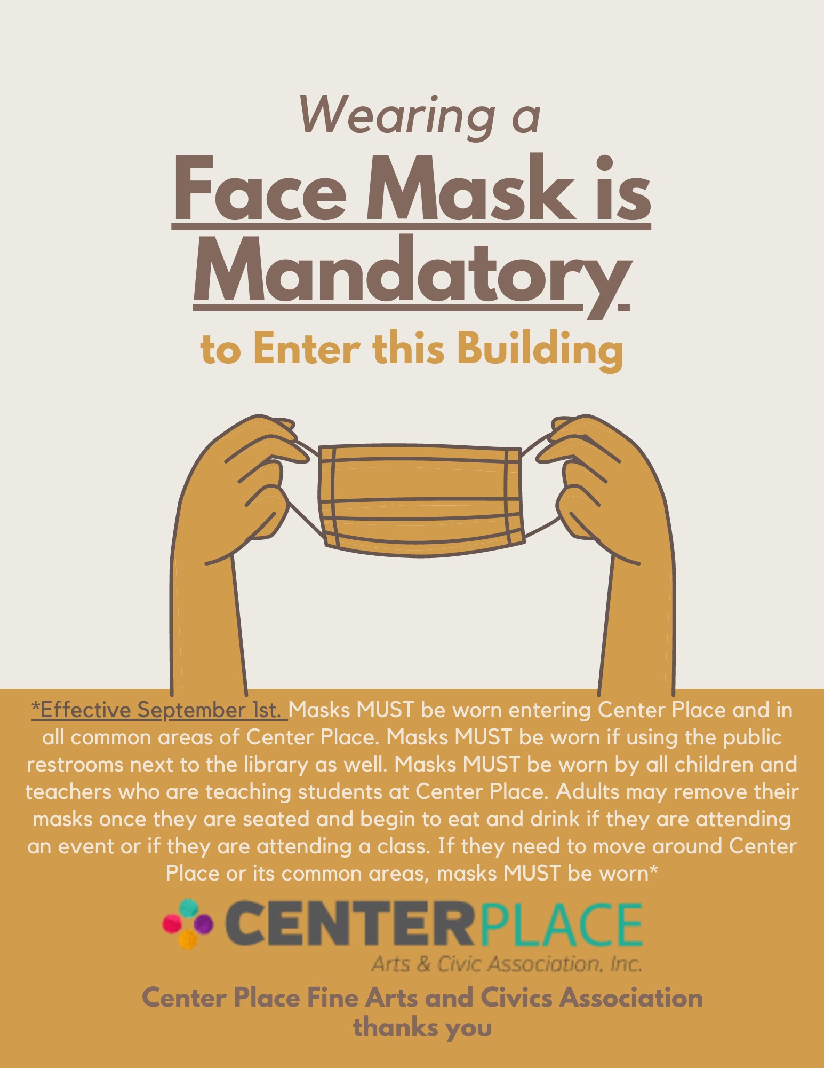 CENTER PLACE
Fine Arts and Civics Association, Inc.
619 Vonderburg Dr. Suite B, Brandon, FL 33511
Office: (813) 685-8888
www.centerplacebrandon.com
Executive Director Email: Libby.Hopkins@centerplacebrandon.com

Grand Room Rental Rates & Fees
Rates Based of Maximum 85 Guests per Event

Day of Week | Rental | Fee | Extended Hours
Mon - Thu | $300 |  | $50 / Per hour
Friday | $600 |  | $75 / Per hour
Saturday | $800 |  | $100 / Per hour
Sunday | $600 |  | $75 / Per hour

Nonprofit Rates for Events-Must Provide a Copy of 5013c Paperwork *these rates ARE not available for weddings, funerals, birthday or showers! Just strictly fundraising events to benefit a nonprofit.*

Day of Week | Rental Fee | Extended Hours
Mon - Thu | $125 | $25 / Per hour
Friday | $200 | $50 / Per hour
Saturday | $200 | $50 / Per hour
Sunday | $200 | $50 / Per hour

Reservation / Damage Deposit: $500 Nonprofit Deposit: $250
Required at signing of contract. Payable Credit Card, Cash or Check
*A 3% credit card fee will be added to damage deposit AND final payment for all rentals.*
Credit Card Authorization Form is REQUIRED for any and all rentals.

Alcohol Overseer Fee: $100

COVID Cleaning Fee: $180

Event Insurance Website: https://www.theeventhelper.com/

Rental Fee is for 6 consecutive hours (between the hours of 9am - midnight).

No venue rentals on the following days: New Year’s Eve, New Year’s Day, Easter Day, Independence Day; Thanksgiving Day, Christmas Eve and Christmas Day.
Prices are subject to change

Items to Be Cleaned After Rental by Renter
Center Place will provide cleaning supplies, trash cans, trash bags, mops and vacuum
-Trash cans emptied with clean bag replaced
-Tables and chairs cleaned and sanitized with bleach
-Ice machine full of ice with ice scoopers
-Kitchen counters cleaned and sanitized with bleach
-Stove, Microwave and oven cleaned
-Grey counter top in hallway cleaned and sanitized with bleach
-Hallway swept
-Dance floor swept and cleaned
-Grand Room swept and vacuumed
-Work room tables and chairs cleaned/sanitized with bleach
-Work room floor swept
-Trash cans in work room emptied with clean bag replaced
-Center Place restroom clean and sanitized with bleach
-Center Place restroom trash can emptied with clean bag replaced
-Public restroom cleaned after event
-AV equipment in working order after event and turned off

*If you have a caterer they are responsible to clean the rooms they use
*ALL FOOD AREAS MUST BE MOPPED AND CLEANED WITH BLEACH

