*Special Events at

Alhambra Palace Restaurant

1240 w. Randolph

Chicago, Il 60607

312-666-9555 x 220

A
lhambra Palace is a one of a kind, dynamic venue that transports all who enter into another world. Sweeping archways, marble accents, mosaic tile, crystal chandeliers and hand carved sculptures frame the multi-level, 24,000 square foot Moorish- like castle. Artifacts from Egypt, Lebanon and Morocco can be seen throughout.

Upon entering, guests are welcomed by a bar and lounge with intimate alcove seating. To the east is the restaurant which seats 100 people. The Babylon room is part modern, part historic with its curvaceous metal back chairs and stone carved wall hangings depicting scenes from the 13th century.

The Alhambra Room, which seats 500 people, is awe –inspiring, soaring three stories high. A full stage with a state of the art sound and lighting system allows Alhambra to host and offer live entertainment. Seating on the expansive ground level and the two tiered circular balconies provide ample room for meeting and small group gathering as well as large scale conferences. Ample space allows for a dance floor, and tables can be added or removed to accommodate a sit down occasion or standing reception.

Guided by a waterfall, stairs lead through the Alhambra Hall to the Marrakech Room, a posh and romantic space for more than 200 people. The high ceiling ballroom can be divided with a luxurious floor to ceiling ruby velvet curtains. Oriental rugs framed with leather cushioned settees Oriental rugs and elaborate wood carved Moroccan chairs offer a spot to relax and enjoy.

Two private VIP rooms, which accommodate up to 50 people, are also located on the upper level. These elaborately decorated rooms exemplify opulence, making any guest feel like royalty.

A world of intrigue and beauty await you for the most memorable experience.

Please call 312-666-9555 for our event coordinators who will assist you in your special occasion at Alhambra Palace.

The Making of Alhambra Palace
A
lhambra Palace was inspired by the eponymous palace and fortress complex of the Moorish monarchs of Granada in southern Spain. Rising from a plateau of nearly 1 million square feet, the Alhambra is enclosed by fortified walls and flanked by 13 towers.

During the reign of the Nasrid Dynasty (1232-1492), the Alhambra was transformed into a palatine city. Without contact from the outside, artists endlessly reproduced the same forms, resulting in a new exquisite style of Moorish symmetry, geometrics and elaborate flora.

Today, the Alhambra of Spain stands as a museum of unparalleled architecture.

Intrigued by the history and art of Alhambra, Dr. Nasar Rustom envisioned to one day bring the culture, art and splendor to Chicago. Over several years and many trips to the Middle East and North Africa, Dr. Rustom amassed a collection of artifacts to display and furnish his restaurant.

He also commissioned artisans in Syria, Lebanon, Egypt and Morocco to recreate the Moorish style of art for the hand carved wood furniture, sculptures, rugs, stone mosaics, arabesques, and crystal chandeliers found throughout the restaurant.

Intricate gilding framing doorways, windows, and hand painted tiles paneling walls throughout the Alhambra exemplify the care and detail found in the ancient palace that Dr. Rustom recreated in Chicago.
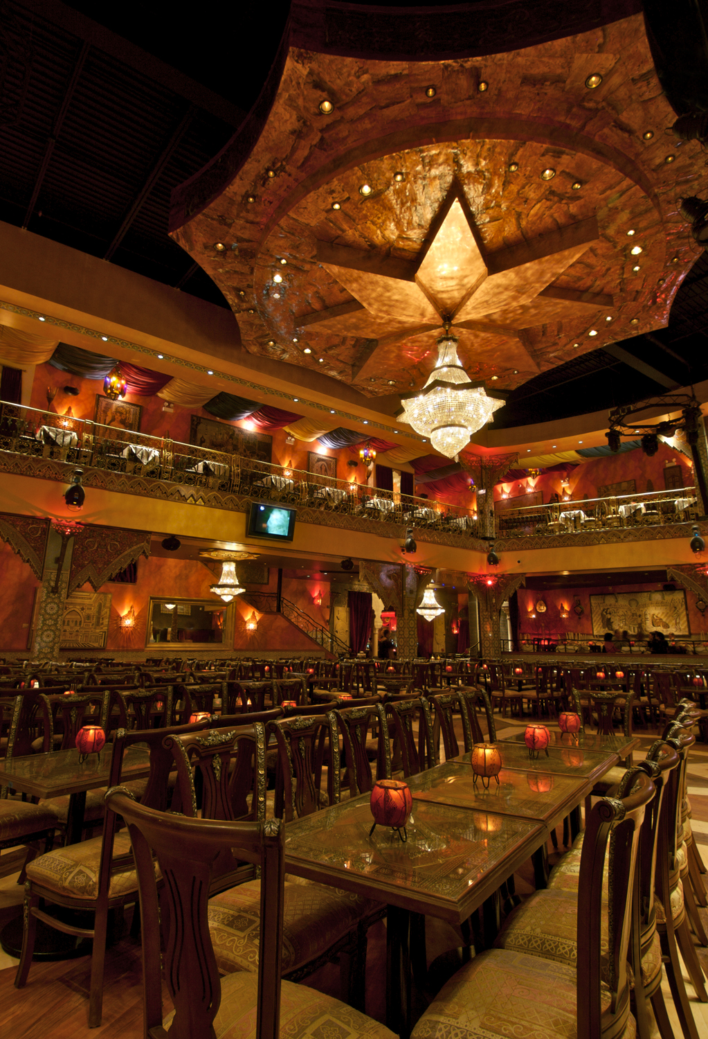
Butler Passed Hors d’oeuvres
Minimum 50 people
One Hour of Service $16 per person (choose 4 items)
Two Hours of Service $22 per person (choose 6 items)
*price per person does not include 10.75% tax and 20% service charge

Cold
Hummus and Baba Ghanoush
Served on a pita chip or whole wheat crisp
Smoked Salmon – Home Cured Salmon
Served on point toast
Shrimp Cocktail
Shrimp served in a mini tumbler with our homemade charmoula sauce
Cucumber with feta cheese and olive
Served with feta cheese and garnished with an olive
Mini Caprese
Fresh mozzarella pearl marinated in basil & olive oil served with a cherry tomato
Alhambra Bruschette
Hummus, Tomato, Cucumber, and Feta Cheese served on mini pita\
Fresh Fruit Kabob
Pineapple, Strawberry, and Raspberry, on a skewer
Hot
Spanakopita
Baked phyllo dough stuffed with spinach and feta cheese
Mini Kabobs
Signature grilled Chicken or Kefta Kabobs served with a pearl onion on a skewer
Mini Falafel
Mini fried chick pea patties, stuffed with onions, garlic, and spices
Mini Beef Wellington
Prime filet of beef wrapped in phyllo dough
Seared Bay Scallop Kabob
Chef’s specially seasoned scallops served on a skewer
Stuffed Mushrooms
Stuffed breaded mushroom caps
Coconut Chicken
Breaded with coconut flakes served on a skewer

Upgrade – Hot Items
Miniature Maryland Crabcakes - $4 per person
Lamb Chops Lollipops - $4 per person

Buffet Options
Minimum 30 people
Price reflects service for two hours

Buffet 1
$43 per person (not including 10.75% tax and 20% service fee)

Mezza
Hummus, Baba Ghanoush, and Lebna

Salad
Fattoush Salad with Fresh Herbs
Lebanese bread salad of peppers, tomatoes, cucumbers, radish, scallions, za’atar, lemon, and mint

or

Cucumber, Yogurt, Garlic, & Mint Salad

Entrees

Chicken Kabob
Marinated chicken in lemon and garlic, grilled kabob style

Kefta Kabob
Ground beef combined with a blend of seasonings, charred kabob style

Penne Alfredo
Penne Pasta with your choice of a creamy white sauce, tossed with grilled mushrooms and broccoli. or, with marinara sauce tossed with vegetables and mussels.

Buffet 2
$46 per person (not including 10.75% tax and 20% service fee)

Mezza
Hummus, Baba Ghanoush, Falafel, and Lebna

Salad
Alhambra Salad
Cucumber, tomato, chick peas, feta cheese, onions and olives tossed in our house dressing over romaine

Entrees

Chicken Kabob
Marinated chicken in lemon and garlic, grilled kabob style

Lamb Kabob
Free range domestic marinated tender leg of lamb from Wisconsin.
Shrimp Kabob
Moroccan Jumbo Shrimp

*These packages are served with Alhambra Rice, Grilled Seasonal Vegetables, Assorted Baklava/ Desserts, and Fresh Pita Bread
Buffet Options (continued)
Minimum 30 people
Price reflects service for two hours

Buffet 3
$50 per person (not including 10.75% tax and 20% service fee)

Mezza
Hummus, Baba Ghanoush, Falafel, and Assorted Cheese Platter with Bread and Crackers

Salad
Fattoush Salad with Fresh Herbs
Lebanese bread salad of peppers, tomatoes, cucumbers, radish, scallions, za’ atar, lemon and mint

Seasonal Soup

Entrees

Chicken Tagine
Whole chicken breast, roasted in vegetable broth.

Filet Kabob
Hand carved, seared prime beef tenderloin served kabob style with Chef’s select sauce

Crusted Salmon Florentine
Atlantic salmon filet with saffron caper sauce

*This Package are served with Raisin Couscous, Grilled Seasonal Vegetables, Assorted Baklava/ Desserts, and Fresh Pita Bread

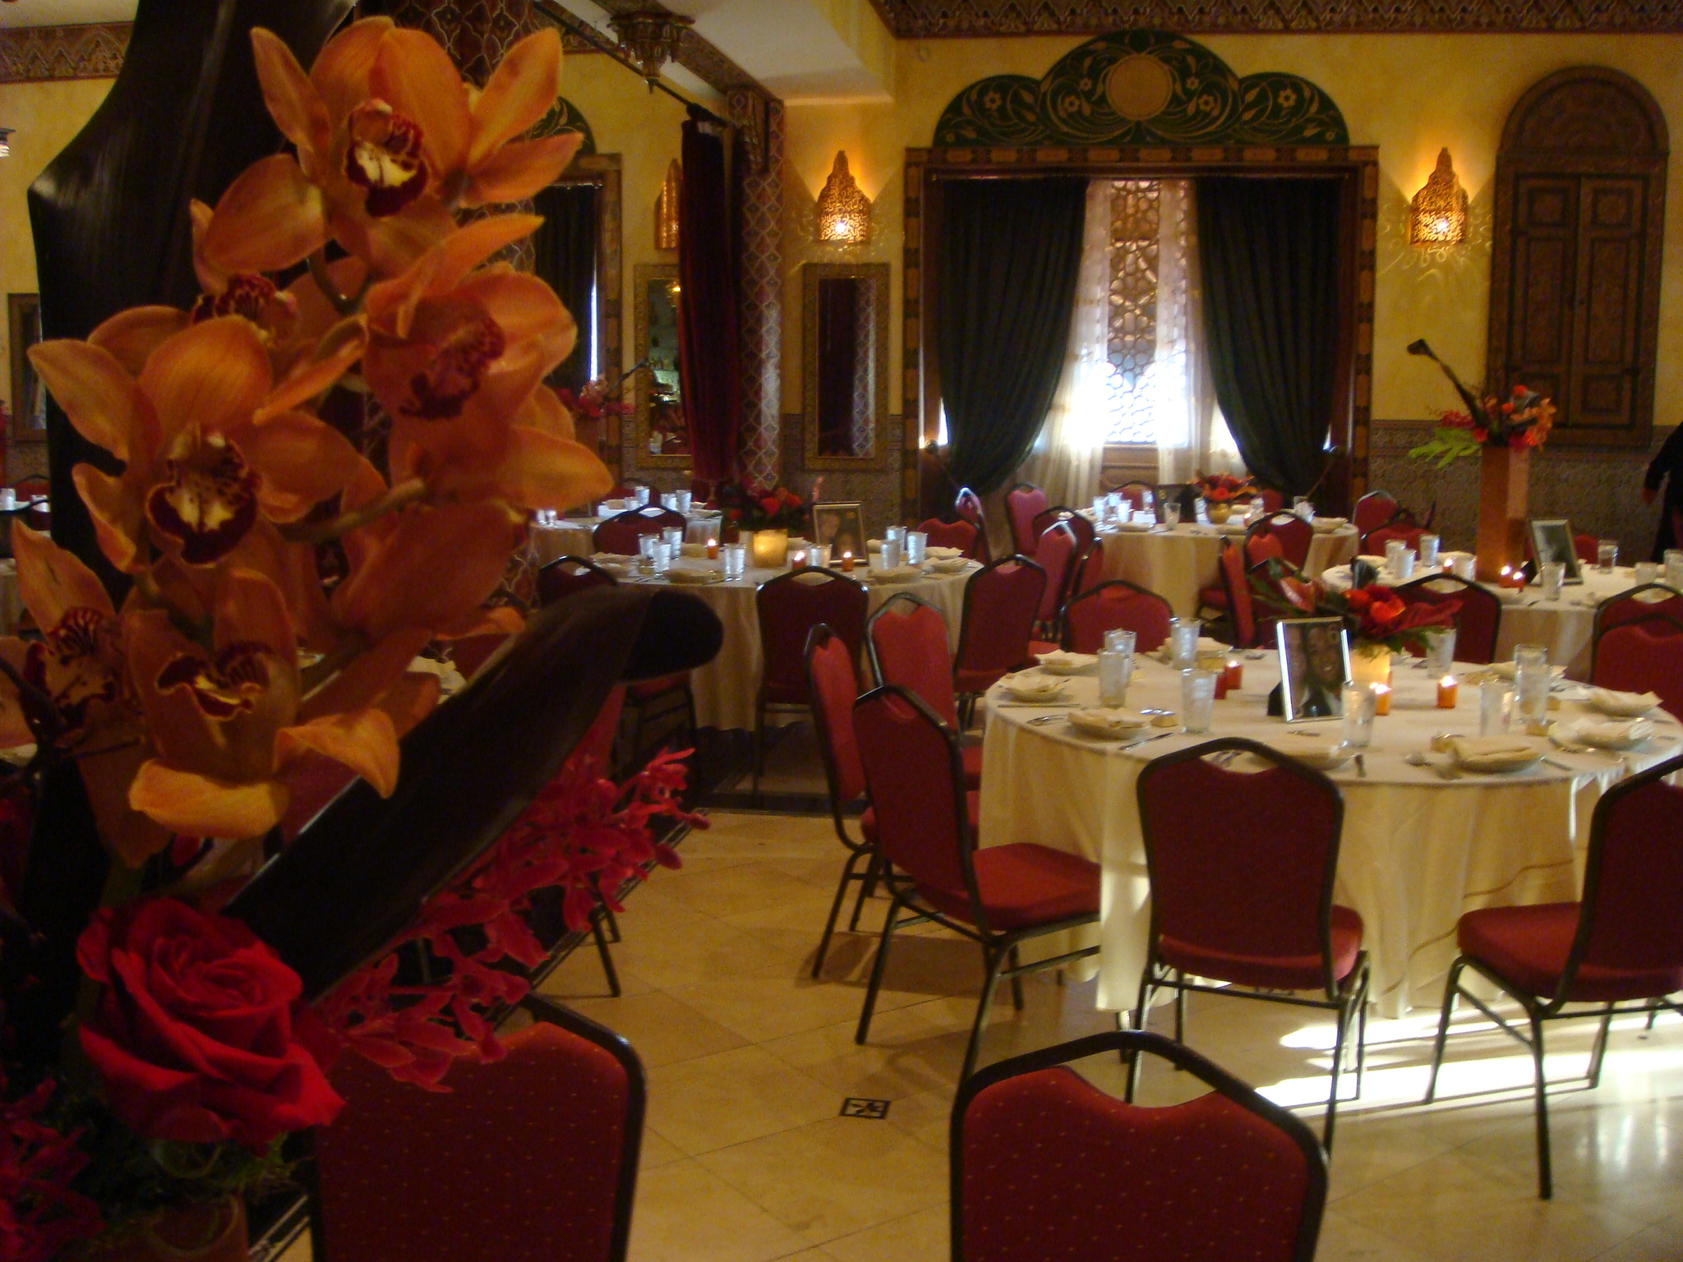
Sawani Style
Served platter style

$55 per person – includes All Mezza, Salad, Entrees, and Dessert
$47 per person – includes Hummus, Baba Ghanoush, Dolmeh Salad, Entrees, and Dessert
$42 per person – includes Salad, Select Entrees, and Baklava
*price per person does not include 10.75% tax and 20% service charge

Mezza

Hummus
The classic chick puree with tahini, lemon, garlic and olive oil
Baba Ghanoush
Smoky roasted eggplant, pureed with our distinctive blend of spices
Tabouli
Chopped parsley, onions, bulgur wheat, tomatoes, lemon and olive oil
Dolmeh
Grapes leaves filled with rice, tomatoes, onions, and fresh herbs
Falafel
Fried chick pea patties stuffed with onions, garlic, and spices
Grilled Shrimp – add $3 per person
Grilled shrimp marinated in garlic, clove, coriander, cumin, and a paprika spice mixture

Salad
Fattoush Salad with Fresh Herbs
Lebanese bread salad of peppers, tomatoes, cucumbers, radish, scallions, za’atar, lemon and mint
Entrees
Served with Alhambra Rice and Grilled Vegetables

Choice of three

Chicken Kabob
Marinated chicken in lemon and garlic
Kefta Kabob
Ground beef combined with a blend of seasonings

Lamb Kabob
Free range Wisconsin marinated tender leg of lamb

Beef Swarma
Marinated and layered on a rotisserie
Filet Kabob – Add $4 per person

Grilled Salmon

North African seasoned Atlantic Salmon

Vegetable Kabob
Chef’s creation of fire roasted vegetable

Dessert Platters – Chef’s Selection of Assorted Mini Pastries, Cakes, and Baklava

Wedding Packages
*price per person does not include 10.75% tax and 20% service charge

Package 1 - $85 per person
One Hour Butler Passed Hors d’oeuvres (choose any 4 items)

Cold
Hummus and Baba Ganoush , Smoked Salmon, Shrimp Cocktail, Cucumber with feta cheese and olive, Mini Caprese, Alhambra Bruschette, Fresh Fruit Kabob
Hot
Spanakopita, Mini Kabobs , Mini Falafel, Mini Beef Wellington, Seared Bay Scallop Kabob, Stuffed Mushrooms, Coconut Chicken

Plated Salad
Fattoush Salad
Lebanese bread salad of peppers, tomatoes, cucumbers, radish, scallions, za’atar, lemon and mint
Entrées (Choice of )

Family Style Dinner

Chicken Kabob
Marinated chicken in lemon and garlic

Kefta Kabob
Beef Filet kabob style cooked to perfection

Penne Alfredo
Penne Pasta with your choice of a creamy white sauce, tossed with grilled mushrooms and broccoli. or, with marinara sauce tossed with vegetables and mussels

Dessert
Assorted Baklava

Three Hour Open Bar (Call Package) and Champagne Toast

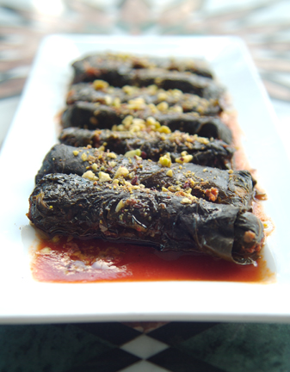
Wedding Packages
*price per person does not include 10.75% tax and 20% service charge

Package 2 - $100 per person

One Hour Butler Passed Hors d’oeuvres (choose any 4 items)

Cold
Hummus and Baba Ghanoush, Smoked Salmon, Shrimp Cocktail, Cucumber with Feta Cheese and Olive, Mini Caprese, Alhambra Bruschette, Fresh Fruit Kabob

Hot
Spanakopita, Mini Kabobs, Mini Falafel, Mini Beef Wellington, Seared Bay Scallop Kabob, Stuffed Mushrooms, Coconut Chicken

Plated Salad
Fattoush Salad with Fresh Herbs
Lebanese bread salad of peppers, tomatoes, cucumbers, radish, scallions, za’atar, lemon
and mint

Family Style Dinner

Entrées (Choice of )

Chicken Tagine
Boneless chicken breast, roasted in vegetable broth.

Filet Kabob
Seared beef medallions, hand carved served with garlic mashed potatoes and seasonal vegetables

Crusted Salmon Florentine
Atlantic salmon filet with a saffron caper sauce served spinach mashed potatoes and seasonal

Dessert
Assorted Mini, Pastries, Cakes, and Baklava
Three Hour Open Bar (Premium Package) and Champagne Toast

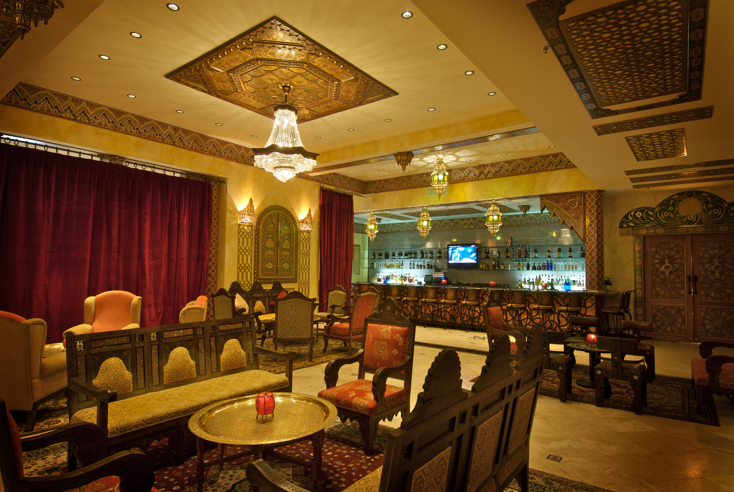
Stations
Minimum 50 people
*price per person does not include 10.75% tax and 20% service charge

Carving Stations
Price reflects two hours of service
Chef Attendant Required - $150

Turkey $27 per person
Beef Tenderloin $37 per person
Moroccan Lamb $47 per person
*Stations Served with various accompaniments, Alhambra Rice and Grilled Vegetables

Hors d’oeuvres Stations

Pita Station $15 per person
Hummus, Baba Ghanoush, Lebna, Marinated Olives, and Dolmeh

Mezza Station $18 per person
Hummus, Baba Ghanoush, Falafel, Tabouli, Dolmeh, and Kibbeh

*Stations Served with Fresh Pita Bread

Dessert Stations

Chocolate Fondue $12 per person
Chocolate fountain served with seasonal fresh fruit and pound cake

Assorted Desserts - $10 per person
Chef’s selection of assorted homemade mini desserts, baklava, and cakes

Lunch
Minimum 30 people
$24 per person
Choice of Buffet* or Sawani Style
*Buffet style price reflects service for two hours, Price does not include 10.75% tax and 20% service charge. Price is only valid before 4:00 p.m.
Includes coffee and tea

Mezza
Choice of two

Hummus
The classic chick puree with tahini, lemon, garlic and olive oil
Baba Ghanoush
Smoky roasted eggplant, pureed with our distinctive blend of spices
Tabouli – add $3 per person
Chopped parsley, onions, bulgur wheat, tomatoes, lemon and olive oil
Dolmeh
Grapes leaves filled with rice, tomatoes, onions, and fresh herbs
Falafel – Add $3 per person
Fried chick pea patties stuffed with onions, garlic, and spices
Grilled Shrimp – Add $4 per person
Grilled shrimp marinated in garlic, clove, coriander, cumin, and a paprika spice mixture

Salad
Fattoush Salad
Lebanese bread salad of peppers, tomatoes, cucumbers, radish, scallions, za’atar, lemon and mint
Entrees
Served with Alhambra Rice and Grilled Vegetables

Choice of two

Chicken Kabob
Marinated chicken in lemon and garlic

Kefta Kabob
Ground beef combined with a blend of seasonings

Lamb Kabob – add $4
Marinated tender leg of lamb

Beef Shawarma
Marinated and layered on a rotisserie

Fresh Sea Scallops – add $ 4
Served with a balsamic reduction

Vegetable Kabob
Chef’s creation of fire roasted vegetables

Dessert Platters
Chef’s selection of assorted mini desserts and Baklava

*continental breakfast can be added to any lunch for an additional $10 per person

Beverage Packages
*price per person does not include 20% service charge. Tax is included.

Soft Drinks
Soft Drink Package Includes: Pepsi, Diet Pepsi, Sierra Mist, Tonic Water, Lemonade, and Cranberry Juice

Maximum of Four Hours $6 per person

Beer and Wine
Beer and Wine Package Includes: domestic and imported beers, house wines

One Hour $17 per person
Two Hours $25 per person
Three Hours $33 per person

Call Package
Call Package includes: Basic cocktails (no martinis) made with standard brand name liquor, domestic & imported beer, house wines, soda & juice
One Hour $24 per person
Two Hours $33 per person
Three Hours $42 per person

Premium Package
Premium Package includes: Cocktails made with premium brand liquor, domestic & imported beer, house wines, soda, juice & bottled water
One Hour $29 per person
Two Hours $39 per person
Three Hours $49 per person

*Shots are not included with any drink package

Hosted bar based on consumption

Domestic Beer - $6
Imported - $7
Call Drinks - $9 and up
Premium - $11 and up
Wines - $9 and up
Additional Services and Information
Minimums and Room Rentals
Each room for any function requires a minimal room rental fee. In addition to each room rental a food and beverage minimum is required for any function. These minimums may vary upon determining the events time if the day, day of the week, and time of the year.
Deposit
A 25% deposit based on estimated charges is due at signing. An additional 50% deposit is due 14 days prior to the event and the final balance based on guaranteed guest count is due 24 hours prior. Additional charges will be assessed at the conclusion of the event. All deposits made are non refundable.
Table Linens
Specialty linen may be brought in through any reputable outside vendor. Otherwise, Alhambra Palace works with Windy City Linen for all events, costs vary. Please ask your event coordinator for pricing and details.
Special Occasion Cakes
We are happy to provide service via our cake and baked goods vendor celebrating all occasions. Prices vary per request, two week notice is required. You may also arrange to bring in your own cake per a licensed vendor (must provide receipt) – Cake cutting fee may apply.
Valet Parking
Habibi Valet, Inc.is our contracted valet service. Valet is available either as a hosted option or as a nominal fee to your guests, at $10.00 per car. Hosted option fees may be negotiated through a Habibi Valet representative.
Audio Visual
Alhambra conveniently houses an array of state of the art Audio and Visual equipment for all purposes. Please discuss with your event coordinator any Audio Visual needs, advance notice is required. Additional charges may apply.
Flowers
We will be pleased to assist you with any floral needs you may have through our preferred vendor The Flower Firm. (www.flowerfirm.com)
Entertainment
We will be pleased to assist with any entertainment needs you may have. In house entertainment includes Belly Dancing provided by Surayah Belly Dance Co., Tribal Belly Dancing (Read My Hips), and house DJ. (Subject to availability) If you are to provide your own entertainment, it must be approved by the Alhambra Management Team.
Outside Food/ Beverage
Outside food of any kind is not permitted at Alhambra Palace unless specified for religious purposes. Specialty desserts and cakes are the only exception and must be provided by a licensed vendor or caterer. Outside wine is the only exception to alcohol. A corkage fee of $25 will be applied to each wine bottle brought in for the event.
Vendors
You are responsible for providing Alhambra a complete list of all vendors and details of who will be working your event. Including but not limited to, photographers, entertainment, florists, etc. Alhambra will not be responsible for accommodating any vendors unannounced.

