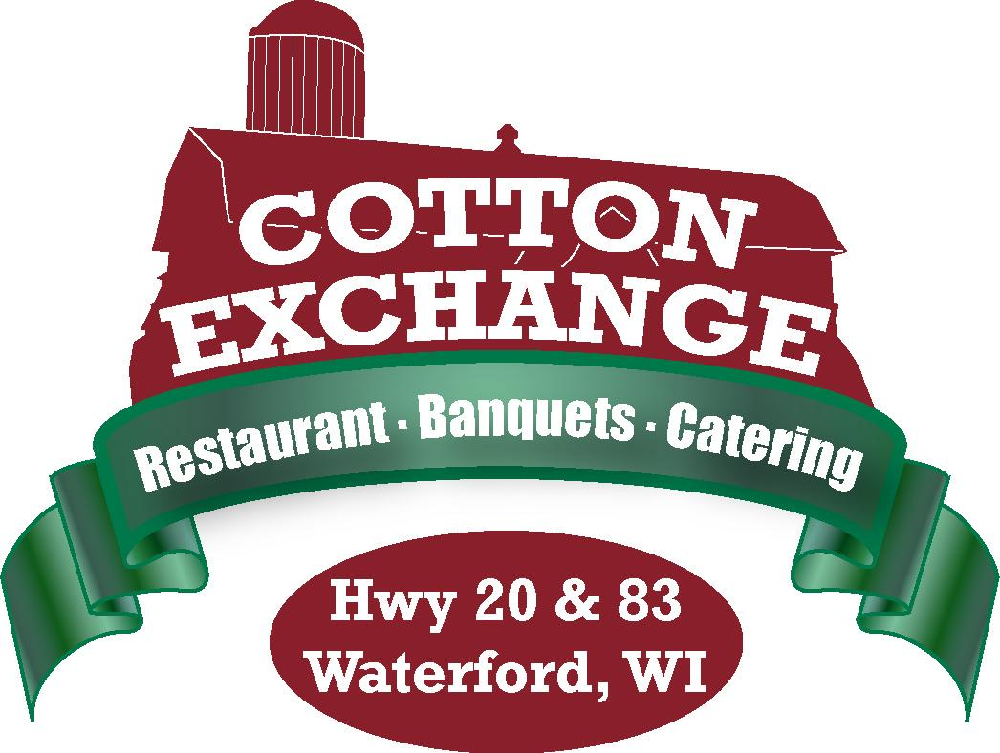

Open / Host
Bar Packages
Price Per Person

Bottled Domestic & Import Beers: Miller High Life, Miller Genuine Draft, Miller Lite, Miller 64, Bud, Bud Light, Bud Light Lime
Pabst, Coors Light, Michelob Ultra, Angry Orchard, Red Apple, O’Douls, O’Douls Amber
Clausthauler, Clausthauler Amber, Guiness, Heineken, Sam Adams, Spotted Cow, Corona Hacker-Pschorr, Leiny Honey Weiss, Leiny Red, Leiny Summer Shanty, Alaskan APA
Alaskan Amber, Crooked Tree IPA, Lake Front IPA, Lake Front East Side Dark, Blue Moon
Stella, New Castle, Mikes Hard Lemonade, Mikes Cranberry, Smirnoff Original, Smirnoff Raspberry

House/Rail Liquors and House Wines:
Fleishman’s Brandy, Gin, Whiskey, Vodka & Rum, Ten High Bourbon, House of Stuart Scotch, Matador Tequila, Bols Amaretto, Blackberry Brandy & Peach Schnapps, Early Times Whiskey, Captain Morgan Rum, Kesslers Whiskey, Blue, Red & Purple Wave, Seagram 7 Whiskey Douglas Hill House Wines by the glass: White Zinfandel, Pinot Noir Chardonnay, Moscato, Riesling, Pinot Grigio, Merlot, Cabernet Sauvignon, Shiraz

Premium Liquors:
Finlandia & assorted flavors Vodka, Jeremiah Weed Vodka, Bacardi & Flavors Rum, Smirnoff & flavors Vodka, Beefeaters Gin, Canadian Club Whiskey, Malibu Rum, V.O. Whiskey, Jim Beam Whiskey, All Doctors Flavors, Jose Cuero Tequila, Parrot Bay Rums, J. Bavet Brandy, Korbel Brandy, Southern Comfort

Top Shelf Liquors:
Grey Goose Vodka, Absolut & Absolut Citron, Bombay Gin, Jack Daniels Whiskey,
J&B Scotch, Ketel One & Ketel One Citron, Bombay Saphire Gin, Crown Royal Whiskey, Tanqueray Gin, Jameson Whiskey, Bushmills Whiskey, Makers Mark Bourbon, Dewars Scotch, Johnny Walker Red Scotch, Baileys and Kaluha

Liquors, Cordials & Cognacs: (not included on standard open bars, may add for additional cost or on a cash basis only)
Woodford Reserve Bourbon, Chivas Regal Scotch, Glenfiddich Scotch, Glenlivet Scotch, Johnny Walker Black Scotch, B&B, Chambord, Disaronno, Drambuie,
Frangelico, Tia Maria

$12.00 First Hour Open Bar, add $4.00 per adult for each additional hour
Guests under the age of 21: $2.95 unlimited Soda

*Shots are NOT included in open bar packages
*All special liquor requests will require a per bottle surcharge

19% taxable service charge and 5.1% sales tax to be added

345 Hickory Hollow, Waterford, WI 53185 (Corner of Hwys. 20 & 83)
Phone: 262-534-9291 Fax: 262-534-9322 www.cottonexchangewi.com

