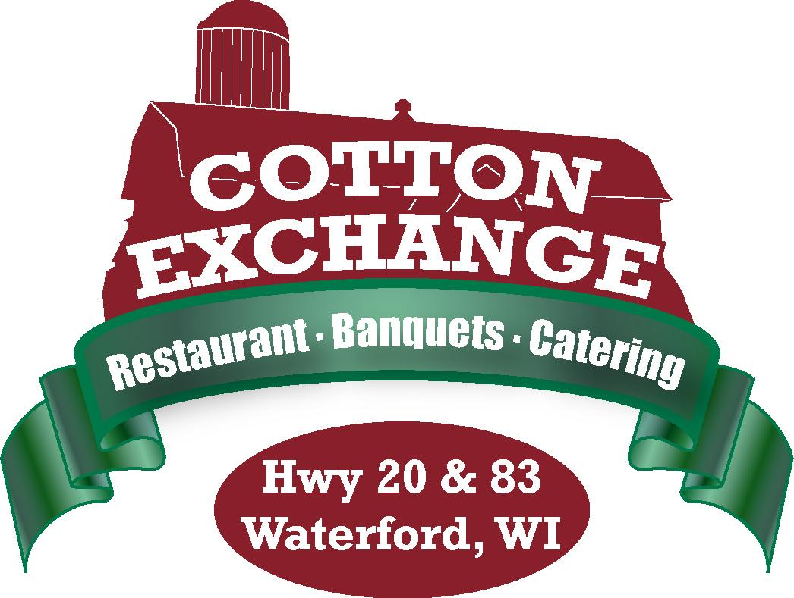

Hors d’oeuvres
Menu

Per 50 Pieces Unless Noted

Cold Hors d’oeuvres
~Cold Trays serve 40-50 guests~
Vegetable Tray with Dip
$65.00
Cheese & Sausage Tray
with Crackers
$65.00
Assorted Fruit Tray
(Available May – September)
$75.00
Seven Layer Mexican Dip
Served with Tortilla Chips
$55.00
Whole Smoked Salmon
$135.00
Deviled Eggs
$45.00
Chilled Shrimp Cocktail
$135.00 per 100

Hot Hors d’oeuvres
Chili Cheese Dip
Served with Tortilla Chips
$40.00
Mini Chicken Taco’s
$55.00 per 100
Wonton Mozzarella Sticks
With Marinara
$75.00
Sante Fe Chicken Egg Rolls
With Ranch Dressing
$75.00

Hot Hors d’oeuvres
Meatballs
Sweet & Sour, Barbecue
Or Swedish
$75.00 per 100
Chicken Drummies
$65.00
Spicy Hot Wings
$75.00
Water Chestnuts Wrapped
In Bacon
$60.00
Mini Chicken Cordon Bleu
$75.00
Mushroom Caps Stuffed
With Crab
$75.00
Chicken Kabobs
$75.00
Beef Kabobs
$85.00
Scallops Wrapped in Bacon
$85.00
Crab Rangoons
$85.00
Coconut Shrimp
$85.00
Potato Skins
$55.00

Snacks
Gardettos $25.00 per 3 lbs.
Potato Chips $12.00 per 2 lbs.
Pretzels $12.00 per 2 lbs.
Tortilla Chips with Salsa $25.00 per 2 lbs.
Roasted Peanuts $12.00 per lb.
Cashews $16.00 per lb.

Chef Carving Station
~Carving stations are priced per person~

Round of Beef Smoked Ham Breast of Turkey
$3.95 $2.95 $3.50

Carving stations include Silver Dollar Rolls and appropriate condiments
*Chef charge of $50.00 to apply

Pasta Station
Bowtie Pasta & Spaghetti
Meatless Marinara
Meatballs, Shrimp & Grilled Chicken Breast Pieces
Parmesan Cheese & Garlic Bread Sticks
$6.95

Salad Bar
Tossed Garden Salad
Sliced Cucumbers, Red Onions, Cherry Tomatoes, Cheddar Cheese, Bacon Bits & Croutons
With choice of Ranch, French & Raspberry Vinaigrette
Baked Rolls & Butter
$3.95

Smashed Potato Bar or Baked Potato Bar
Smashed Red Potatoes or Baked Idaho Potatoes
Cheddar Cheese, Diced Tomatoes, Butter, Sour Cream, Bacon Bits & Chives
Assorted Seasonings
$3.50

Mac & Cheese Bar
Baked Mac & Cheese with assorted toppings
Bacon, Ham, Broccoli, Scallions, Cheddar Cheese, Tomato, Jalapenos, Mushrooms
$6.95
Add diced Shrimp $3.00 Add diced Lobster $5.00

Nacho Bar
Seasoned Ground Beef & Shredded Chicken
Nacho Cheese, Shredded Lettuce, Diced Tomatoes, Black Olives, Diced Red Onions
Sliced Jalapenos, Salsa & Sour Cream
$6.95

*All Stations have a minimum of 50 guests and are based on guaranteed number of guests
*To ensure a successful Wedding Horsdoeuvres Reception as an alternative to a plated or buffet dinner
A minimum of $20.00 per person is required

19% taxable service charge and 5.1% sales tax to be added

