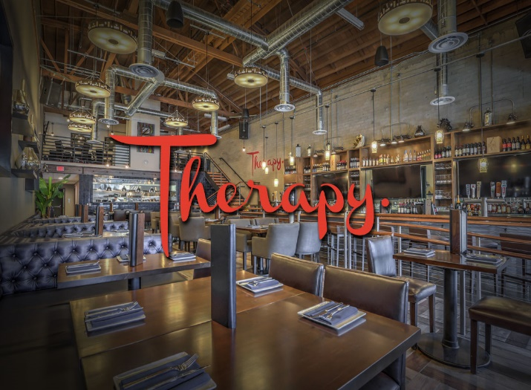

Savor. Sip. Share www.Therapylv.com
FAMILY STYLE Menu: The following selections will be attractively presented and shared Family style from the center of each table. All selections are to be ordered in advance by the host.

APPETIZERS
(Choice of Two)

OXTAIL EMPANADAS
BRAISED OXTAIL, JALAPENO & SCALLION FILLED PASTRY WITH HARISSA CREAM

DEVILS ON HORSEBACK
GOAT CHEESE AND ALMOND STUFFED DATES WRAPPED IN BACON ON ROMESCO SAUCE ​

IN THE "GNUDI"
BAKED RICOTTA, TRUFFLED FIG JAM, ROASTED ALMONDS, CRANBERRY & WALNUT CROSTINI
​
CHICKEN MEATBALLS
SERVED WITH JALAPENO CILANTRO PESTO AND SHAVED PARMESAN

​THERAPY'S CRAB DIP
ARTICHOKE, LUMP CRAB, PARMESAN, HEATED TO PERFECTION WITH BLUE TORTILLA CHIPS. GF ​
(Add $5.00 ++ per person)

SALADS
(Choice of One)

THERAPY'S SIGNATURE SALAD
WATERMELON, RADISH, APPLES, CANDIED WALNUTS & BLUE CHEESE CRUMBLES, TOSSED IN WHITE BALSAMIC VINAIGRETTE.

THE CAESAR
FRESH PARMESAN, CREAMY BLACK PEPPER DRESSING, SERVED WITH GARLIC PARMESAN TOAST
ENTREES
Choice of Two @$ 45.00 ++ per person
Choice of Three @$ 55.00 ++ per person

++PLUS 8.15% TAX AND 22% GRATUITY

SCOTTISH SALMON
ROASTED SALMON, QUINOA, FARRO, TUSCAN KALE & FIG BALSALMIC

SLICED CHIMICHURRI STEAK
CERTIFIED ANGUS BEEF SERVED WITH A CHARRED SCALLION CHIMICHURRI SAUCE AND FRIED ONION STRINGS

HUNTERS CHICKEN
ROASTED chicken served on a bed of RED POTATO MASH, WITH A RED WINE MUSHROOM JUS

THERAPY'S SIGNATURE BONE IN PORK CHOP
APPLE JAM, RED POATATO MUSTARD MASH & ROASTED JUS

THE SHORTY
rED WINE BRAISED SHORT RIB, RED POTATO MASH, cARAMALIZED HIERLOOM CARROTS, WATERCRESS
(Add $10.00 ++ per person)

FILET MIGNON
10 OZ BEEF TENDERLOIN, WITH ONION JAM AND RED WINE JUS
(Add $10.00 ++ per person)

SIDES
(Choice of Two)

CHARRED BRUSSEL SPROUTS
TOSSED WITH ROASTED CASHEWS

SUPER MAC
ORECHIETTE PASTA WITH THERAPY'S SIGNATURE CHEESE BLEND

LOADED MASH POTATO
BACON LARDONS, CHIVE
& AGED WHITE CHEDDAR

DESSERT
(Choice of Two)

CAST IRON S'MORES
GRAHAM CRACKER CRUST WITH DARK SEMI-SWEEET CHOCOLATE & TOASTED MARSHMALLOWS ​

CRUMBLED CARROT CAKE
HOUSE MADE CRUMBLED CARROT CAKE, BROWN BUTTER GELATO & CREAM CHEESE FROSTING

CHOCOLATE BANANA BREAD PUDDING
HOUSE MADE CHOCOLATE BANANA BREAD PUDDING TOPPED WITH CARAMELIZED BANANAS AND HOUSE MADE BANANA SORBET WITH OUR SALTED CARAMEL THERAPY WHISKEY SAUCE ​
(Add $5.00 ++ per person)

​

THERAPY_LV : 

Bar Service
Optional:
- Host Sponsored Open Bar 2-hour @$45.00++ per person
- Host Sponsored Consumption Bar at prevailing prices as listed on the current Beer, wine Sangria and Cocktail menus.
- Customized beverage menu available
To be charged to the Host Credit Card on file.

Cash Bar available

Dinner Wine Service available.

Miscellaneous & Equipment Required:
Special decoration, table settings, private bar and bartender, etc.

TERMS & CONDITIONS:
The final Banquet Event Order must be signed by the client event coordinator and returned to Therapy Sales Department with their approval in writing within seven (7) days of receipt.
The Banquet Event Order is a binding agreement. Therapy management reserves the right to change your location in the restaurant assignment at will at our discretion based on the total number of your guaranteed attendance. If cancellation should occur within thirty (10) days of your event, full estimated charges will be due.

DEPOSIT
A deposit is required to hold the date of the event. This deposit is non-refundable. . All deposits are deducted from the final payment amount. Acceptable forms of payments are Visa, and MasterCard.

FINAL PAYMENT
Final Payment for your event is due seven ( 7 ) days prior to your event date and any additional charges that incur the day of the event will be charged to the credit card on file for all events.

FINAL GUEST COUNT
Your guaranteed number of guests will be required seven (7) business days prior to your event; should we not hear from you by seven (7) days, the expected attendance will be considered the guarantee. Your final billing will be based on your guaranteed number of attendees, or actual attendance, whichever is greater.

 is home of the followings Las Vegas tours and has been featured in tv channels, newspapers, magazines and social media:

