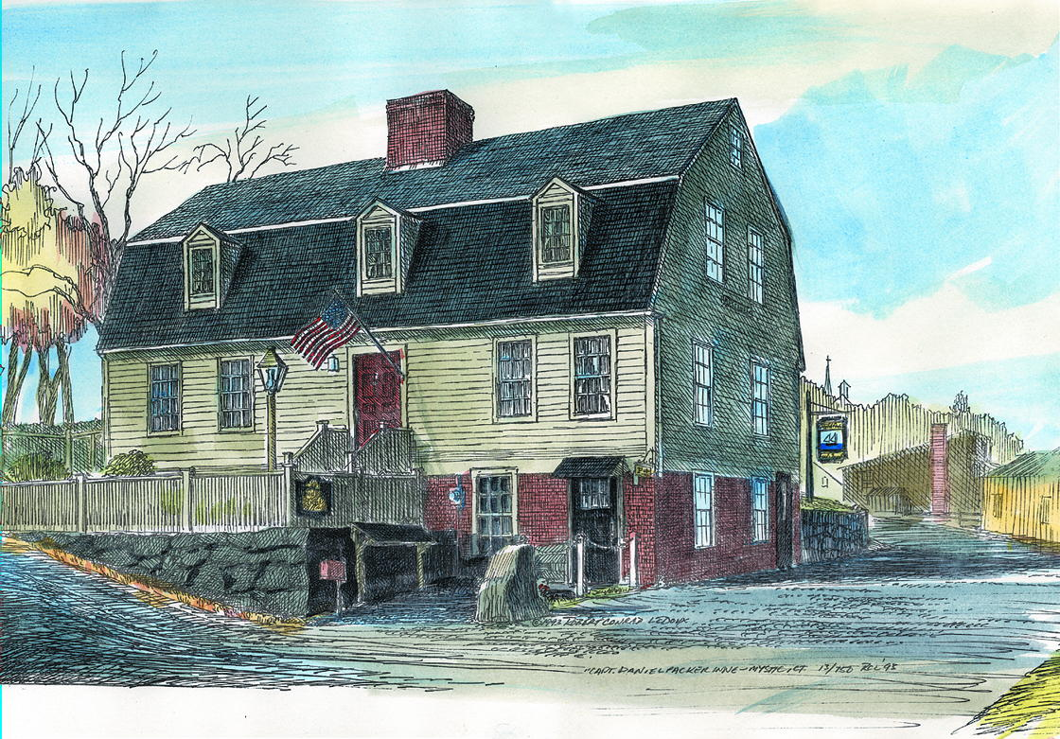

Captain Daniel Packer Inne

PARTY INFORMATION

Thank you for your interest in the Captain Daniel Packer Inne. Enclosed you will find our Banquet Menus. Please confirm your menu choices and final guest count no later than two weeks prior to your scheduled event.

Our delicious desserts are freshly made on premise. You may bring your own store bought cake for your event. If you decide to bring your own cake, please understand that there will be a $2.00 plate charge per guest.

Private parties requiring Kristen’s Room (maximum 16 people) or the Captain’s Room (maximum 20 people) will have a minimum of $600.00 Sunday night through Friday night and a minimum of $1,000.00 on Saturday nights. Private parties requiring our 3rd floor (maximum 45 people) will have a minimum of $600.00 Sunday night through Thursday night and a
minimum of $1,500.00 on Friday nights. Saturday nights are a minimum of $3,000.00. Daytime functions have a $300. 00 minimum for Capt. Room and a $500.00 minimum in
the River Room. This amount includes the total for all food, beverages, and 6.35% CT sales tax. The minimum excludes a suggested 20% server gratuity. Please note minimums are subject to change for holidays and specialty event dates.

In the event that a booked party is cancelled with less than 48 hours notice a $100.00 cancellation fee will be charged.

We offer audio/visual equipment if you require it for your event. The projector rental fee is $75/day and the screen rental fee is $25/day. Projector and screen rentals do not count toward the minimum.

Please call (860) 536-3555 with any questions you may have. We look forward to hearing from you. Again, thank you for considering the Captain Daniel Packer Inne.

Sincerely,

Allison K. Nasin
Judy Hartley

32 Water Street Mystic, CT 06355 ∙ 860-536-3555 ∙ danielpacker.com

Captain Daniel Packer Inne

Hors D’oeuvre Menu

MINIMUM OF 20 PIECES EACH ON THE FOLLOWING:

$1.50 PER PIECE

Baby Bella Roasted Mushrooms
Creamy Alouette cheese, crispy breading, chive infused olive oil
balsamic reduction

†Chicken Skewers
Thai coconut, sweet chili sauce

Danish Meatballs
Cocktail meatballs in a sour cream gravy

$2.00 Per Piece

Tuscan Crostini
Garlic parmesan crostini, olive tapenade, roasted marinated tomatoes

Waldorf Tartlet
Spiced walnuts, green apple, curry, blue cheese, and dried cranberries,
baked in a tartlet cup

Vegetable Spring Rolls
Sweet Soy Glaze

$2.50 Per Piece

*†Sesame Seared Tuna
Cucumber, pickled ginger, Thai chili sauce

*Chilled Peppered Beef Tenderloin
Toasted garlic crostini, horseradish cream, chive oil

†Wild Boar Skewer
Broken Arrow Ranch wild boar sausage, whole grain mustard

†Items may be prepared Gluten Free

*Thoroughly cooking meats, poultry, seafood, shellfish or eggs reduces the risk of food borne illness

32 Water Street Mystic, CT 06355 ∙ 860-536-3555 ∙ danielpacker.com

$3.00 Per Piece

†Jumbo Shrimp Cocktail

Pickling spices, cocktail sauce

†Bacon Wrapped Scallop
Sea scallops, smoked bacon

*DPI Mini Beef Wellington
Tenderloin, Seacoast Farm mushroom duxelle, puff pastry

Selections

Artisanal Cheeses
Chef selected fine cheeses, seasonal fruit, crackers
20 Guests $120 40 Guests $200

Flatbread Station
Fire grilled parmesan crusted flatbread, artichoke jalapeno cream cheese dip,
assorted hummus, mixed olive & peppadew tapenade
20 Guests $100 40 Guests $180

Mediterranean Array
Imported meats, sausages, mixed marinated olives,
roasted grilled vegetables, sliced Lighthouse Bakery baguette,
herb garlic olive oil, whole grain mustard
20 Guests $160 40 Guests $280

**Hors-D’oeuvres must be ordered up to 2 weeks in advance of your party. If you have a special request please speak with our party coordinator.

†Items may be prepared Gluten Free

*Thoroughly cooking meats, poultry, seafood, shellfish or eggs reduces the risk of food borne illness

32 Water Street Mystic, CT 06355 ∙ 860-536-3555 ∙ danielpacker.com

9/21/16

Captain Daniel Packer Inne

Banquet Lunch Menu

Starters

DPI New England Clam Chowder $8
Salt crackers

†DPI Baked Onion Soup $8

†Jumbo Shrimp Cocktail $3 per shrimp
Spicy cocktail sauce

†Charcuterie $15
Broken Arrow Ranch wild boar sausage, elk sausage, cured meat assortment,
cornichons, whole grain mustard

†The DPI Original Stuffed Portobello Mushroom $8
Alouette cheese, seasoned breadcrumbs, chive oil, balsamic syrup

*Seared Sesame Tuna $13
Chilled and served with soy, cucumber salad, and sweet Thai chili sauce

†Mussels $12
Dijon cream, shallots, fried string potatoes

Salads

†DPI Salad $8
Red leaf lettuce, sun dried cranberries, roasted pistachios cucumber,
Gorgonzola cheese, raspberry vinaigrette

Almond Encrusted Goat Cheese $12
Field greens, orange cashew vinaigrette

†Caesar $8
Crisp romaine, Parmesan cheese, Caesar dressing, garlic herb croutons

Additions: Pan Seared Stonington Sea Scallops….$14…Grilled Chicken…$6
Jumbo Shrimp...$11…Sirloin Steak…$8…Salmon…$8

32 Water Street Mystic, CT 06355 ∙ 860-536-3555 ∙ danielpacker.com

Entrées

*†Grilled Filet of Beef $31
DPI mashed potatoes, creamy Gorgonzola sauce, port wine-toasted
walnut demi glacé

*†Black Pepper Crusted “Blackjack” Strip Steak $29
DPI mashed potatoes, Jack Daniels-shiitake mushroom demi glacé

Lemon Peppered Chicken $21
DPI mashed potatoes, lemon beurre blanc

*†Pan Seared Faroe Island Salmon $24
Pan seared, lemon herb butter, haricot verts, heirloom grape tomatoes
Shiitake mushroom risotto

†Roasted Cod $16
Panko breadcrumbs, citrus beurre blanc, haricot verts, heirloom grape tomatoes,
DPI mashed potatoes

Crab Cakes $18
Chipotle aioli, haricot verts, heirloom grape tomatoes

Scallops Nantucket $25
Sea scallops, lightly breaded, baked with lemon, white wine
and cheddar cheese

Angel Hair Aglio Olio $17
Roasted tomatoes, garlic, Parmesan, fresh herbs, olive oil
add Chicken $23 add Shrimp $28 add Scallops $31

Lobster Mac ‘n Cheese $16
Orecchiette pasta, creamy cheddar & Swiss cheese, herb butter cracker crust

All entrees served with French baguette, sweet cream butter, and roasted garlic

**A TWENTY PERCENT GRATUITY WILL BE SUGGESTED FOR PARTIES OF SEVEN OR MORE

*Thoroughly cooking meats, poultry, seafood, shellfish or eggs reduces the risk of food borne illness

32 Water Street Mystic, CT 06355 ∙ 860-536-3555 ∙ danielpacker.com

12/15/16

Banquet Dinner Menu

Soups

†Baked Onion Soup $8
New England Clam Chowder $8

Salads

†DPI Salad $9
Red leaf lettuce, sun dried cranberries, roasted pistachios cucumber,
Gorgonzola cheese, raspberry vinaigrette

Almond Encrusted Goat Cheese $12
Field greens, orange cashew vinaigrette

†Caesar $8
Crisp romaine, Parmesan cheese, Caesar dressing, garlic herb croutons

Entrees

Chicken

Lemon Peppered Chicken $20
DPI mashed potatoes, haricot verts, heirloom grape tomatoes, lemon beurre blanc

Chicken Marsala $25
Sauteed with mushrooms, shallots, and Marsala wine over Angel Hair Pasta

Beef

*†Grilled Filet of Beef $31
DPI mashed potatoes, creamy Gorgonzola sauce, port wine-toasted
walnut demi glacé, haricot verts, heirloom grape tomatoes

*†Black Pepper Crusted “Blackjack” Strip Steak $29
DPI mashed potatoes, Jack Daniels-shiitake mushroom demi glacé, haricot verts, heirloom grape tomatoes

*†Center Cut Sirloin $28
DPI mashed potatoes, haricot verts, heirloom grape tomatoes, chimichurri

32 Water Street Mystic, CT 06355 ∙ 860-536-3555 ∙ danielpacker.com

Seafood

†Shrimp Creole Risotto $27
Sautéed gulf shrimp with green /pepper, celery and onion in a red
Creole gravy over risotto

*†Pan Seared Faroe Island Salmon $28
Lemon herb butter, haricot verts, heirloom grape tomatoes,
Seacoast Farms shiitake mushroom risotto

†Scallops Nantucket $31
Sea Scallops baked with herb butter, white wine and
seasoned bread crumbs topped with cheddar cheese

Vegetarian

Angel Hair Aglio Olio $17
Roasted tomatoes, garlic, Parmesan, fresh herbs, olive oil
add Chicken $23 add Shrimp $28 add Scallops $31

†Portobello Stack $18
Seasonal grilled vegetables, roasted tomato coulis

†Items may be prepared Gluten Free

*Thoroughly cooking meats, poultry, seafood, shellfish or eggs reduces the risk of food borne illness

Prices subject to change.

32 Water Street Mystic, CT 06355 ∙ 860-536-3555 ∙ danielpacker.com

12/09/16

