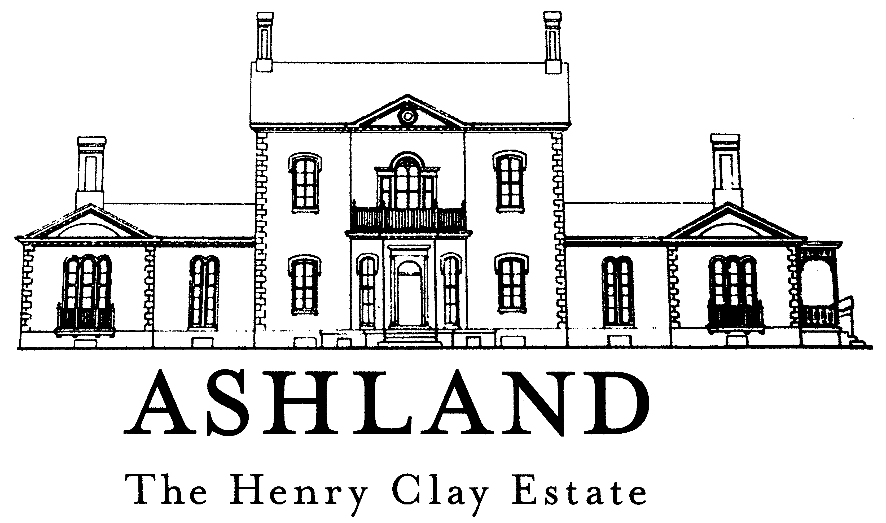
120 Sycamore Road, Lexington, Kentucky 40502
PH 859-266-8581 FAX 859-268-7266
www.henryclay.org

Professional Photography/Videography/Film Contract

The Henry Clay Memorial Foundation, a private, nonprofit organization, owns and manages Ashland, the Henry Clay Estate and its grounds. In order to help the Foundation defray the considerable costs associated with maintaining the Estate, a fee from photographers and videographers is required for use privileges. The terms and conditions of this contract are listed on page 3 and the fee schedule is below.

Photographers using our property solely for photos in a non-tourist capacity

______$300.00 for unlimited use for one calendar year (Subject to Terms and Conditions of Contract). Wedding parties are not included.

______$100.00 for wedding-party portraits and group shots

______$25.00 per one-time session

Commercial Photographers & Videographers (for print/broadcast advertisements or other commercial purposes, re-sale of image, etc.)

PRIOR APPROVAL REQUIRED

______$300.00 per one-time session (one day only)

All photography fees are to be paid at least 24 hours in advance. We accept cash, checks, and credit cards. For those paying with credit card, payment may be made over the phone. Please make checks payable to The Henry Clay Memorial Foundation and mail it or drop it off, along with this completed form, to 120 Sycamore Road, Lexington KY 40502. If you have any questions, please contact us at 859-266-8581. Please call during normal business hours to schedule your sessions in advance.

Studio contact name

_______________________________________________________________________
Studio/company name

_______________________________________________________________________

Complete mailing address

_______________________________________
Phone #

_______________________________________
E-mail address

_______________________________________
Website

_______________________________________
Photographer/videographer’s name (If different from above)

________________________________________________
Date & time of session or filming (For Commercial Videography/Print Ads/Re-Sales of Image sessions, etc.)

___________________________________________________________________________

______________________________________________ ______________
Studio Contact Signature Date

Approved by:

______________________________________________ ____________________________
Authorized signature - Henry Clay Memorial Foundation Date of approval

Thank you for your support of Ashland, The Henry Clay Estate.

Ashland Photography Contract Nov. 2016

Terms and Conditions

1. ALL use of the garden and grounds of Ashland, The Henry Clay Estate must be scheduled in advance by calling 859-266-8581.

2. ALL photographers are asked to sign-in at the ticket office upon arrival to obtain a professional photography pass before the photo session begins unless the session takes place after regular business hours. Please return the pass to the Museum Store upon completion of session.

3. For print advertisements, video to be used in commercials, images to be used for re-sale purposes or other uses with a large distribution/circulation, prior approval is required. Interior photography is not permitted unless special arrangements have been made ahead of time. Please call 859-266-8581 to discuss project and approval.

4. Sessions within the formal garden are allowed during the hours of normal museum operation only. (See # 11) One hour sessions are scheduled on a first come, first served basis. Please note that by scheduling a one hour session, it does not mean that the garden will be off limits to regular visitors. Photographers or their representatives may not bar visitors from entering the garden or enjoying any other part of the Estate.

5. All furniture and container plantings may be used only in their existing locations. They are NOT to be moved.

6. Photographers and subjects must stay off the grass in the formal garden. Use the gravel and brick paths. Tripods or other equipment may NOT be placed in the planting beds.

7. There is no limousine or party bus parking allowed in paved parking area. Drivers may drop off riders in the lot, but must park in grasscrete areas or on the street until conclusion of session.

8. Photographers are asked to submit payment 24 hours prior to the date of the scheduled session. Checks may be mailed or delivered to the Ashland Museum Store. They must be clearly designated as payment for photo sessions and the scheduled date referenced. In some instances, with prior permission, payment may be made the day of the session.

9. Due to limited parking on site, all parking for photo sessions scheduled during regular business hours must be in grass-crete area adjacent to the paved parking lot. The paved lot is reserved for patrons of the museum and Ginkgo Tree Café.

10. Any on-site photography deemed inappropriate by Ashland staff will not be allowed. No photography is allowed which will block doorways of or entry into any historic structures on the site.

11. The formal garden is locked each evening at 5:00. The entrance gates to the site are closed at the same time. All sessions scheduled on the grounds of the estate after 5:00 require on-street parking.

12. The terms of this contract are good for the calendar year in which the contract is submitted.

13. Special Conditions and Charges, if applicable:________________________________________________________________

Note – Terms and Conditions subject to change to ensure the historic integrity of the Estate and to protect its educational mission.

