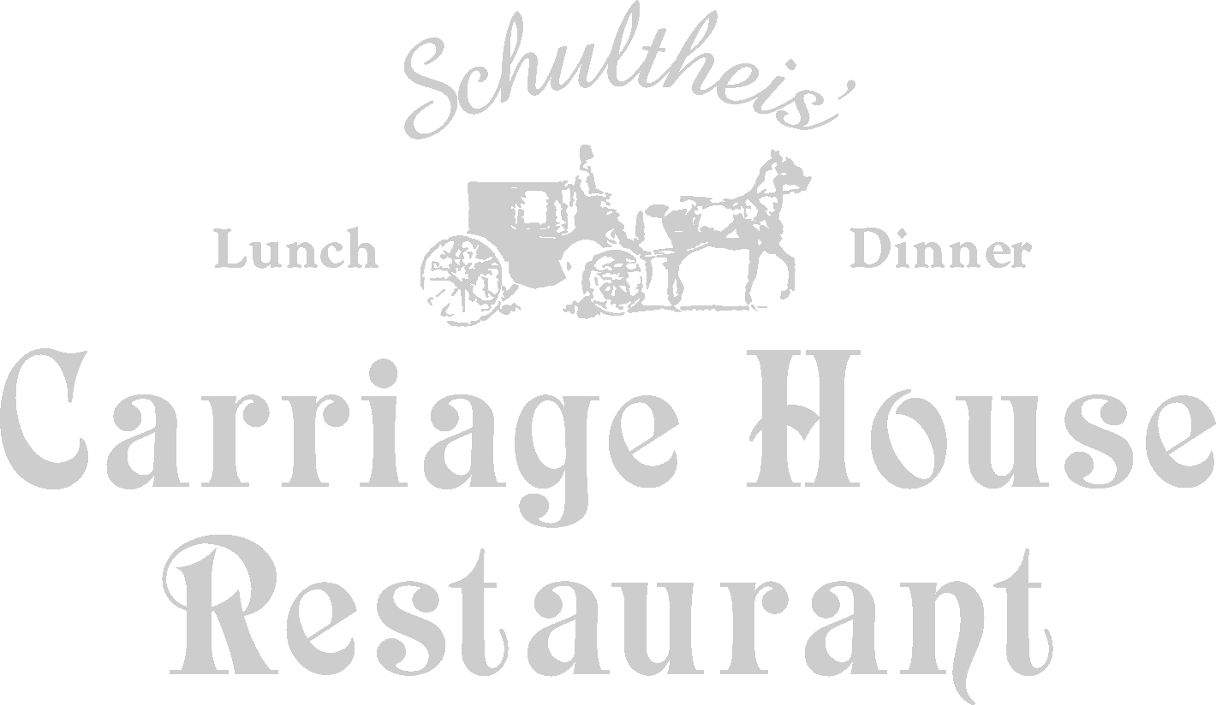
Breakfast Brunch Buffet
19.50 Per person
The menu is as follows:

Assorted juices
Fresh Fruit Display
Danish and assorted pastries, bagels, and breads
Carriage House Salad or Mandarin orange citrus salad
Scrambled eggs
Belgium waffles
Chicken a Lorraine
Beef Burgundy
Cheese Blintzes with Fruit Sauce
Assorted Meats: bacon, sausage
Potatoes O’Brien
Fresh Vegetable of the Day
Desserts: Choose two
Chocolate Mousse, Bread Pudding, Cannoli
Raspberry Torte & Rice Pudding
Coffee and Tea

