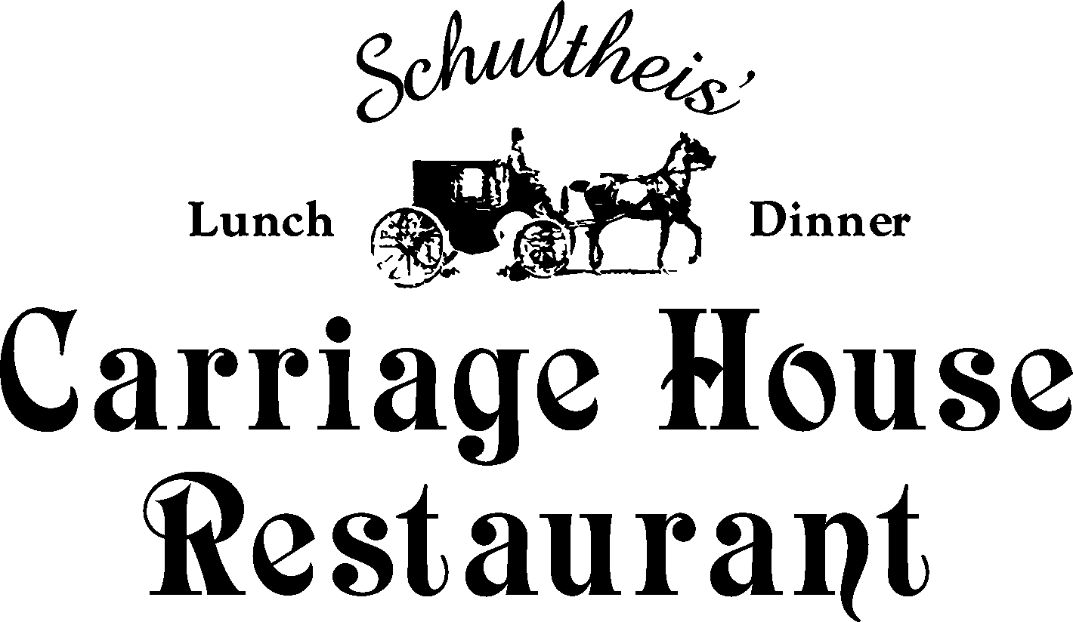

Hors’doeuvres Menu

Tomato Bruschetta
Eggplant Componola
Grilled balsamic assorted vegetable crudités with gorgonzola dressing
Assorted Cheeses , Fresh Fruit and Assorted Crackers
or
Baked Brie with a Fruit Sauce
Assorted puff pastry: cheese puffs, mini dogs, spinach puffs, mini quiches, etc.
Porkupine Meatballs in a lemon caper sauce
Mini-ham and cheese Stromboli
Chicken tenders in a Hoisian Sauce
Italian sausage and roasted red peppers
Spinach and Artichoke Dip with toasted garlic rounds
Smoked salmon & cream cheese
Lemon Grass Spring Rolls with dipping sauces
Boneless unbreaded wings Hot or mild
Stuffed Mushrooms with savory stuffing
Skewered beef satay’s

